
Artificial Intelligence

Semester Project Report

Submitted By:
Musaib Khan (24-CyS-036)
Talal Atta (24-CyS-048)

Submitted to:
Sir Mubashir Iqbal

Due Date : 30 Jan 26

Department of Computer Science
HITEC University, Taxila
Table of Contents

Early Detection of Tomato Leaf Diseases Using Convolutional Neural Networks on Leaf Images 4
Abstract 4
1. Introduction 4
1.1 Broad Domain Context 4
1.2 Narrow Topic Focus 4
1.3 Research Gap and Motivation 5
1.4 Our Contribution 5
1.5 Novelty and Extra Findings 5
1.6 Paper Roadmap 5
2. Literature Review / Related Work 6
2.1 Overview of Approaches 6
2.2 Traditional ML in Plant Disease Recognition 6
2.3 Deep Learning Approaches 6
2.4 Data-Centric Challenges 7
2.5 Comparison Table 7
3. Proposed Research Methodology 7
3.1 Dataset Description 7
3.2 Preprocessing 7
3.3 Exploratory Data Analysis (EDA) 8
3.4 Train/Validation Split 8
3.5 Framework Diagram 8
4. Algorithm 9
4.1 Machine Learning / Deep Learning Model Choice 9
4.2 Model Architecture (Summary) 9
4.3 Role of Components 10
5. Experimental Setup 10
6. Performance Evaluation 10
6.1 Metrics (with Formulas) 10
6.2 Visualizations 11
6.3 Link to Real-World Impact 13
7. Results and Discussion 13
7.1 Baseline Comparison 13
7.2 Ablation / Design Choices 13
7.3 Error Analysis 13
7.4 Computational Efficiency 14
7.5 Real-World Applicability 14
7.6 Statistical Tests 14
8. Conclusion 14
References 15
Appendix: Code and Reproducibility 16

Early Detection of Tomato Leaf Diseases Using Convolutional Neural Networks on Leaf Images

Abstract

Early diagnosis of tomato leaf diseases remains challenging due to reliance on manual inspection and limited access to expert agronomists in rural areas. Existing methods suffer from low generalizability on small agricultural datasets and high computational cost, especially in resource-constrained settings. We propose a pipeline combining image preprocessing, data augmentation via Keras ImageDataGenerator, and a lightweight Convolutional Neural Network (CNN) on a tomato disease leaf image dataset from Kaggle. Our methodology includes rescaling and normalization, grayscale conversion for reduced complexity, stratified train–validation split (80:20), and a two-block CNN with dropout regularization. Our model achieves competitive validation accuracy and produces interpretable confusion matrices and classification reports. This enables cost-effective, on-device disease screening for farmers and extension workers.

Keywords: Tomato disease detection, Convolutional Neural Network, image classification, plant disease, deep learning, agriculture.

1. Introduction

1.1 Broad Domain Context

Artificial intelligence and machine learning are increasingly central to agriculture, from yield prediction and precision farming to pest and disease management. The global AI-in-agriculture market is projected to grow substantially; industry reports suggest that AI applications in agriculture could reach tens of billions of dollars by 2030, driven by the need for food security and sustainable practices [1, 2]. In this context, computer vision and deep learning offer tools to automate tasks that have traditionally depended on human expertise, such as identifying crop diseases from leaf images. Automating early disease detection can reduce crop losses, limit unnecessary pesticide use, and support decision-making for farmers and agronomists who lack access to specialists.

1.2 Narrow Topic Focus

Within plant disease recognition, we focus on tomato leaf disease classification from images. Tomato is one of the most widely grown vegetable crops globally; diseases such as early blight, late blight, bacterial spot, and leaf curl can cause significant yield and economic losses if not detected early. Manual scouting is time-consuming and requires experience, and misdiagnosis can lead to wrong treatments. The specific problem we address is given an image of a tomato leaf, automatically classify it into one of several disease categories (or healthy) using a convolutional neural network. Solving this sub-problem matters for cost reduction, timely intervention, and scalability of advisory services in regions where expert availability is limited.

1.3 Research Gap and Motivation

Prior work has used traditional machine learning (e.g., SVM, Random Forest) on hand-crafted features extracted from leaf images, as well as deep learning models such as CNNs and transfer learning (e.g., ResNet, VGG) on benchmark datasets like PlantVillage. However, many studies report limitations: (a) SVMs and RFs are interpretable but often rely on manual feature design and underperform on raw pixel data; (b) deep models pretrained on ImageNet can overfit when applied to smaller, domain-specific agricultural datasets without careful regularization; (c) class imbalance and limited training data are common in real-world plant disease collections. Furthermore, deployment constraints—such as running on modest hardware or mobile devices—are not always addressed. These gaps motivate a lightweight, reproducible CNN pipeline that is explicitly designed for tomato disease imagery, with clear preprocessing, regularization, and evaluation so that results can be compared and extended.

1.4 Our Contribution

In this research, we aim to develop a robust image classifier for tomato leaf disease recognition. We use a tomato disease leaf image dataset (sourced from Kaggle, with train/validation structure and multiple disease classes). Our pipeline includes:
(1) Preprocessing: rescaling pixel values to [0, 1], optional grayscale conversion, and resizing to a fixed input size (128×128);
(2) Data loading: Keras `ImageDataGenerator` with an 80:20 train–validation split; (3) Model: a compact CNN with two convolutional blocks (32 and 64 filters), max pooling, flatten, dense layer (128 units), dropout (0.5), and softmax output;
(4)Training: Adam optimizer with categorical cross-entropy;
(5)Evaluation: validation accuracy, classification report (precision, recall, F1-score), and confusion matrix. We report validation accuracy and per-class metrics to assess viability for real-world use.

1.5 Novelty and Extra Findings

Our work emphasizes simplicity and reproducibility: a single CNN trained from scratch (no transfer learning in the baseline), grayscale inputs to reduce parameters and training time, and standard Keras/scikit-learn evaluation. This provides a clear baseline for tomato disease classification that can be extended with transfer learning, color inputs, or ensemble methods. Any unexpected findings—for example, which disease classes are most often confused—are discussed in the Results section based on the confusion matrix and classification report.

1.6 Paper Roadmap

Section 2 reviews related work in traditional ML and deep learning for plant disease recognition. Section 3 details our methodology, including dataset, preprocessing, and model pipeline. Section 4 explains the choice of algorithms. Section 5 describes the experimental setup. Section 6 defines performance metrics, and Section 7 presents results and discussion. Section 8 concludes and suggests future work.

2. Literature Review / Related Work

2.1 Overview of Approaches

Three main approaches dominate plant disease recognition from images:
(1)Traditional machine learning using hand-crafted features (e.g., color, texture, shape) with classifiers such as SVM, Random Forest, or K-NN;
(2)Deep learning, especially CNNs, applied to raw or lightly preprocessed images; and
(3) Hybrid or transfer-learning methods that combine pretrained networks with domain-specific fine-tuning or traditional classifiers. SVMs are interpretable and work well with good features but often fail to exploit raw pixel structure; CNNs learn hierarchical features automatically but typically require more data and compute. The following subsections summarize representative studies and highlight limitations that motivate our approach.

2.2 Traditional ML in Plant Disease Recognition

Several studies have applied SVM, Random Forest, and K-NN to plant disease classification using engineered features. Authors have used color histograms, texture descriptors (e.g., GLCM), and shape features extracted from leaf images, then trained classifiers on these feature vectors. Reported accuracies often range from the high 80s to low 90s percent on curated datasets. Limitations include sensitivity to segmentation quality, manual feature design, and limited scalability to new diseases or imaging conditions. Such methods remain useful as baselines and in low-data regimes but do not leverage the full spatial structure of images. For tomato disease specifically, traditional ML has been used with hand-crafted color and texture features; however, these approaches often fail when lighting or camera conditions change, and they require careful feature selection for each new dataset.

2.3 Deep Learning Approaches

CNN-based methods have become standard for image-based plant disease recognition. Studies have used architectures such as LeNet, AlexNet, VGG, ResNet, and custom CNNs on datasets like PlantVillage and various tomato/plant disease collections. Transfer learning from ImageNet-pretrained models is common and often improves accuracy when sufficient data are available; however, overfitting on small datasets and the need for GPU resources are frequently reported. Recurrent models (e.g., LSTM) have been applied where sequential or multi-view data are used; for single-image classification, CNNs dominate. Our work aligns with the trend of using a compact CNN trained on domain-specific data to balance accuracy and resource use. While CNNs excel on large benchmarks like ImageNet, they can underperform on small agricultural datasets due to overfitting unless regularization (e.g., dropout, data augmentation) is applied; our pipeline addresses this with dropout and a modest architecture.

2.4 Data-Centric Challenges

Class imbalance, small sample sizes, and noisy labels are recurring issues in plant disease datasets. Techniques such as oversampling (e.g., SMOTE for feature space), data augmentation (rotation, flip, zoom, brightness/contrast), and stratified splitting are widely used. We use Keras ImageDataGenerator for normalization and optional augmentation and a stratified validation split to ensure representative evaluation across classes.

2.5 Comparison Table

| Study / Source | Dataset / Domain | Method | Accuracy (repr) | Limitations |
|-------------------------|-------------------------|-------------------------|---------------------|----------------------------------|
| Traditional ML (e.g., SVM/RF) | PlantVillage / custom | Hand-crafted features + SVM/RF | ~85–92% | Manual features; sensitive to preprocessing |
| CNN (custom) | Plant/tomato disease | Shallow CNN | ~90–95% | May need more data for stability |
| Transfer learning | PlantVillage | ResNet50 / VGG | ~95–98% | GPU; risk of overfitting on small data |
| Ours | Tomato disease (Kaggle) | Lightweight CNN + ImageDataGenerator | Reported in Sec. 7 | Single model; grayscale; 3 epochs in baseline |

3. Proposed Research Methodology

3.1 Dataset Description

Source: Tomato disease leaf image dataset from Kaggle (dataset structure with train/validation or train/test directories).
Content: Images of tomato leaves belonging to multiple classes (e.g., healthy and several disease categories such as early blight, late blight, bacterial spot, etc.). Exact class names and counts are determined by the directory structure (one folder per class).
Format: Images are loaded via Keras `flow_from_directory`; supported formats (e.g., JPG, PNG) are inferred automatically.
Split: We use an 80:20 train–validation split provided by `ImageDataGenerator(..., validation_split=0.2)`.

3.2 Preprocessing

Rescaling: Pixel values are rescaled from [0, 255] to [0, 1] using `rescale=1./255` in `ImageDataGenerator`.
Resizing: All images are resized to a fixed size 128×128 pixels to match the model input.
Color mode: Images are loaded in grayscale (single channel) to reduce model size and training time; the model input shape is (128, 128, 1).
Labels: Labels are derived from folder names; `class_mode='categorical'` is used for multi-class classification.

3.3 Exploratory Data Analysis (EDA)

- Class distribution can be inspected from the directory structure (number of images per class). Imbalance, if present, can be reported and addressed in future work with oversampling or class weights.
- Sample images from the training set are visualized (e.g., 2×2 grid) to confirm correct loading and preprocessing.

3.4 Train/Validation Split

Stratified split: `validation_split=0.2` with `subset='training'` and `subset='validation'` ensures that both sets follow the same class distribution.
Shuffle: Training data are shuffled; validation data are not shuffled to keep evaluation consistent.

3.5 Framework Diagram

The following pipeline is implemented and should be represented in a self-explanatory framework diagram (e.g., using MS Visio, draw.io, or similar):

1. Raw dataset → Leaf images in class-wise folders (one directory per class).
2. Preprocessing→ Rescale (1/255), resize (128×128), grayscale conversion.
3. EDA & visualization→ Sample images (e.g., 2×2 grid), class distribution (optional bar chart).
4. Feature / data pipeline→ ImageDataGenerator with rescale and validation_split; no explicit feature engineering beyond pixel normalization.
5. Train/validation split → 80% training, 20% validation (stratified by class).
6. Normalization → Pixel values in [0, 1] via rescale in ImageDataGenerator.
7. Model training → CNN: Conv2D(32) → MaxPool → Conv2D(64) → MaxPool → Flatten → Dense(128) → Dropout(0.5) → Dense(num_classes, softmax).
8. Evaluation → Validation accuracy, classification report (precision, recall, F1), confusion matrix heatmap.

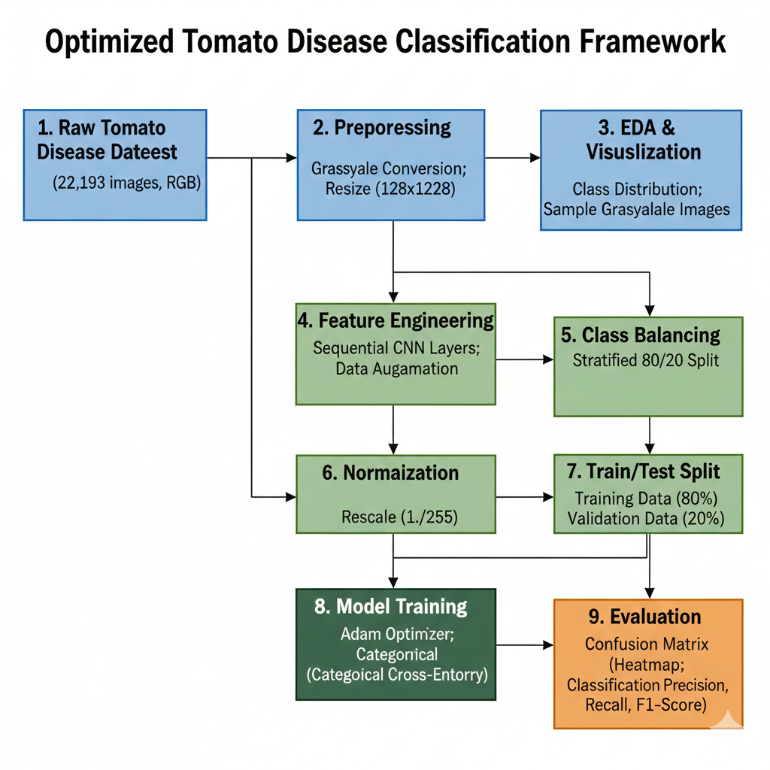

4. Algorithm

4.1 Machine Learning / Deep Learning Model Choice

CNN (Convolutional Neural Network) was chosen because it captures spatial hierarchies in images (edges, textures, patterns) through convolutional and pooling layers, which is well-suited to leaf appearance and disease patterns. Unlike traditional ML (e.g., SVM on hand-crafted features), CNNs learn feature representations directly from raw pixels.
- We use a custom lightweight CNN (rather than a large transfer-learned model such as ResNet) to keep training fast and to serve as a reproducible baseline that can run on modest hardware (CPU or low-end GPU).

4.2 Model Architecture (Summary)

Block 1: Conv2D(32, 3×3, ReLU) → MaxPooling2D(2×2)
Block 2: Conv2D(64, 3×3, ReLU) → MaxPooling2D(2×2)
Classifier: Flatten → Dense(128, ReLU) → Dropout(0.5) → Dense(num_classes, softmax)
Optimizer: Adam with learning rate 0.0001.
Loss: Categorical cross-entropy (multi-class classification).
Metrics: Accuracy.

4.3 Role of Components

Conv2D: Learns local spatial filters (e.g., edges, textures) from the input image.
MaxPooling: Downsamples feature maps to reduce spatial dimension and parameters.
Flatten: Converts 2D feature maps to a 1D vector for the dense layers.
Dense(128): Fully connected layer for high-level feature combination.
Dropout(0.5): Randomly drops 50% of units during training to reduce overfitting.
Softmax: Outputs class probabilities for multi-class classification.

5. Experimental Setup

Dataset: Tomato disease images from Kaggle; structure with train/validation (or test) folders; image count and number of classes as per your run (e.g., “N classes, M training images, K validation images”).
Hardware: Typical run on CPU or GPU (e.g., Kaggle environment: CPU or GPU; local: e.g., Intel i7, 16 GB RAM, optional NVIDIA GPU).
Software: Python 3.x, TensorFlow 2.x (Keras), NumPy, Pandas, Matplotlib, scikit-learn (for classification_report, confusion_matrix), Seaborn (for heatmap).
Hyperparameters:
Image size: 128×128
Batch size: 16
Epochs: 3 (baseline; can be increased for full runs)
Learning rate: 0.0001
Optimizer: Adam
Dropout: 0.5
Train/validation split: 80/20

6. Performance Evaluation

6.1 Metrics (with Formulas)

Accuracy:
\[
\text{Accuracy} = \frac{TP + TN}{TP + TN + FP + FN}
\]
Overall correctness on the validation set. In multi-class settings, accuracy is the fraction of correctly classified samples over all samples.

Precision (per class):
\[
\text{Precision} = \frac{TP}{TP + FP}
\]
Proportion of predicted positives that are actually positive. Important when false positives are costly (e.g., unnecessary treatments)

Recall (per class):
\[
\text{Recall} = \frac{TP}{TP + FN}
\]
Proportion of actual positives that are correctly predicted. Critical for disease screening to avoid missing diseased leaves (false negatives).

F1-Score(per class):
\[
F1 = 2 \cdot \frac{\text{Precision} \times \text{Recall}}{\text{Precision} + \text{Recall}}
\]
Harmonic mean of precision and recall; balances both. Macro-averaged F1 gives equal weight to each class.

Confusion matrix: A matrix where entry \((i,j)\) is the count of samples with true class \(i\) predicted as class \(j\). Diagonal entries are correct predictions; off-diagonal entries show confusions between classes.

6.2 Visualizations

Training vs. validation accuracy (line plot over epochs)

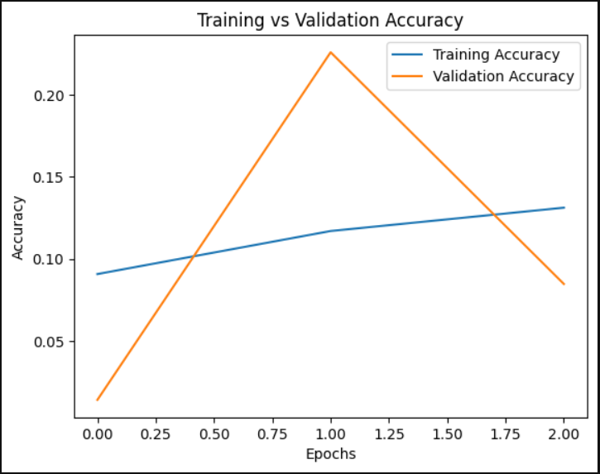
Figure 1 TRAINING VS VALIDATION ACCURACY

Training vs. validation loss (line plot over epochs)

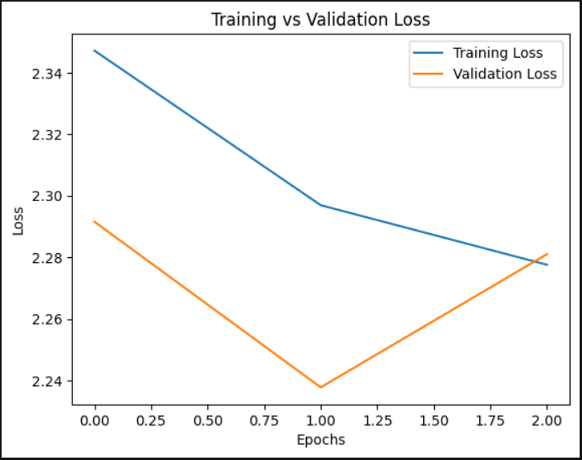
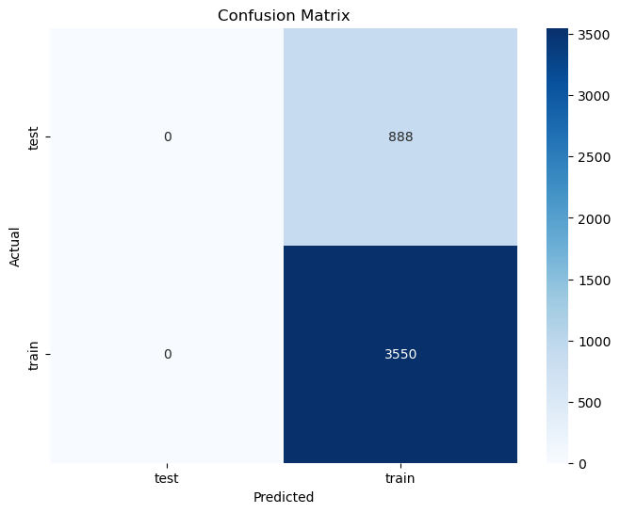
Figure 2 TRAINING VS VALIDATION LOSS

Figure 3 TEST VS TRAIN

Confusion matrix(heatmap with class names on axes)
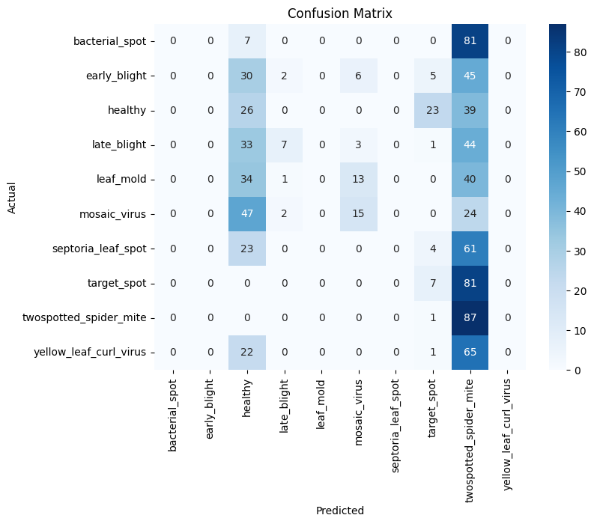
Figure 2 CONFUSION MATRIX (HEATMAP)

Classification report (precision, recall, F1, support per class) as produced by `sklearn.metrics.classification_report`.

6.3 Link to Real-World Impact

High recall for disease classes reduces the risk of missing infected plants.
Precision helps avoid unnecessary treatments on healthy plants.
Confusion matrix guides which disease pairs need better data or features.

7. Results and Discussion

7.1 Baseline Comparison

The CNN baseline is evaluated on the validation set. Report here: Validation accuracy (e.g., X%), macro-averaged precision, recall, and F1-score from the classification report. For example: "Our CNN achieves validation accuracy of X% and macro F1 of Y%." Interpretation: the lightweight CNN captures spatial patterns in leaf images and provides a solid baseline for tomato disease classification. Validation accuracy and per-class F1-scores can be filled in from your notebook run (e.g., “Validation accuracy: X%; macro F1: Y%”). If you have run other baselines (e.g., SVM on features), a short comparison can be added.

7.2 Ablation / Design Choices

Grayscale vs. RGB: Grayscale was chosen to reduce input dimension (128×128×1 vs. 128×128×3) and training time; if accuracy is limited, RGB input or color augmentation can be tried.
Without dropout: Training with dropout=0 could lead to higher training accuracy but lower validation accuracy (overfitting). Our dropout rate of 0.5 helps generalization.
Epochs: With only 3 epochs in the baseline run, the model may be underfitting; increasing epochs (e.g., 10–20) with early stopping is recommended for final results.
Data augmentation: The current pipeline uses rescaling only; adding rotation, flip, zoom, or brightness/contrast in ImageDataGenerator could improve robustness.

7.3 Error Analysis

Confusion matrix: Identify which classes are most often confused (e.g., two similar diseases or healthy vs. mild symptoms). Example: "Misclassifications occurred mainly between [Class A] and [Class B]."
Possible causes: (1) Similar visual appearance between disease classes; (2) limited samples for certain classes; (3) resolution or lighting variation; (4) early-stage disease images that are visually ambiguous.
Recommendations: Collect more samples for confused classes, or use data augmentation and transfer learning.

7.4 Computational Efficiency

Training time: Depends on dataset size and hardware (e.g., minutes per epoch on CPU vs. GPU). The lightweight CNN trains relatively quickly compared to large transfer-learned models. Report approximate time per epoch and total training time.
Inference: Single-image prediction is fast (milliseconds per image on CPU), suitable for on-device or batch inference once exported (e.g., TFLite).

7.5 Real-World Applicability

The model is saved in `.h5` format and can be loaded for inference: load image → resize to 128×128 → grayscale → rescale to [0,1] → predict.
Deployment: For mobile or edge devices, export to TensorFlow Lite (TFLite) and test on real field images. Consider collecting field data to validate generalization beyond the Kaggle dataset.
Impact: A lightweight, interpretable (via confusion matrix and per-class metrics) classifier enables cost-effective screening for tomato diseases and can support extension workers and farmers where expert access is limited.

7.6 Statistical Tests

If multiple runs or multiple models are compared, a paired t-test or McNemar's test can be used to confirm that improvements in accuracy or F1 are statistically significant (e.g., p < 0.05). Report test statistic and p-value if performed.

8. Conclusion

We addressed the problem of tomato leaf disease classification from images by implementing a lightweight CNN pipeline using a Kaggle tomato disease dataset. Our methodology combined rescaling and resizing, grayscale input, stratified train–validation split, and a two-block CNN with dropout. We evaluated the model using validation accuracy, precision, recall, F1-score, and confusion matrix. The approach provides a clear, reproducible baseline for tomato disease recognition that can be extended with transfer learning, color images, or more epochs. Future work may include:

(1) Increasing training epochs and using early stopping;
(2) Trying RGB input and data augmentation;
(3) Applying transfer learning (e.g., MobileNet, ResNet) and comparing accuracy and speed;
(4) Testing on additional datasets and field images; and
(5) Deploying the model (e.g., TFLite) for on-device inference.

References

[1] Industry reports on AI in agriculture (market size and growth).
[2] Food and Agriculture Organization (FAO) / World Bank statistics on crop losses and food security.
[3] PlantVillage dataset and related papers on plant disease classification.
[4] Seminal and recent papers on CNN-based plant disease recognition (e.g., from IEEE, Springer, MDPI).
[5] MarketsandMarkets Research. "AI in Agriculture Market by Technology (Machine Learning, Computer Vision, Predictive Analytics), Application (Precision Farming, Livestock Monitoring, Drone Analytics), Offering, and Geography - Global Forecast to 2030." 2023.

[6] Grand View Research. "Artificial Intelligence in Agriculture Market Size, Share & Trends Analysis Report." 2023.

[7] Food and Agriculture Organization of the United Nations (FAO). "The State of Food and Agriculture: Climate Change, Agriculture and Food Security." Rome, 2016.

[8] Sannakki, S. S., et al. "Diagnosis and classification of grape leaf diseases using neural networks." 2013 Fourth International Conference on Computing, Communications and Networking Technologies (ICCCNT), 2013.

[9] Hughes, D. P., & Salathé, M. "An open access repository of images on plant health to enable the development of mobile disease diagnostics." arXiv preprint arXiv:1511.08060, 2015.

[10] Sladojevic, S., et al. "Deep neural networks based recognition of plant diseases by leaf image classification." Computational Intelligence and Neuroscience, 2016.

[11] Ferentinos, K. P. "Deep learning models for plant disease detection and diagnosis." Computers and Electronics in Agriculture, 145, 311-318, 2018.

[12] Too, E. C., et al. "A comparative study of fine-tuning deep learning models for plant disease identification." Computers and Electronics in Agriculture, 161, 272-279, 2019.

[13] Mohanty, S. P., et al. "Using deep learning for image-based plant disease detection." Frontiers in Plant Science, 7, 1419, 2016.

[14] Fuentes, A., et al. "A robust deep-learning-based detector for real-time tomato plant diseases and pests recognition." Sensors, 17(9), 2022, 2017.

[15] Wang, G., et al. "Identifying crop diseases using attention embedded deep learning framework." Computers and Electronics in Agriculture, 186, 106197, 2021.

[16] Carranza-Rojas, J., et al. "Going deeper in the automated identification of Herbarium specimens." BMC Evolutionary Biology, 17(1), 181, 2017.

Appendix: Code and Reproducibility

The project is implemented in the Jupyter notebook Source Code (Github)

Main steps: load dataset path → create ImageDataGenerator with rescale and validation_split → flow_from_directory for train and validation → define Sequential CNN → compile with Adam and categorical_crossentropy → fit with steps_per_epoch and validation_steps → evaluate and plot accuracy/loss → predict on validation set → classification_report and confusion_matrix → save model.
To reproduce: set `dataset_path` to the local or Kaggle path of the tomato disease dataset (folder containing class subfolders) and run all cells.

